Module–1(Fundamental)

1. What is SDLC.

* SDLC stands for Software Development Life Cycle.
* It is a systematic process for planning, creating, testing, deploying, and maintaining software.

2. What is software testing?

* Software testing is a process of systematically evaluating a software application or system to identify any defects, ensure that it meets specified requirements.

3. What is agile methodology?

* Agile methodology is a project management and product development approach that prioritizes flexibility, collaboration, and customer satisfaction.

4. What is SRS?

* SRS stands for "Software Requirements Specification."
* It is a comprehensive document that outlines the functional and non-functional requirements of a software system.

5. What is oops?

* OOP, or Object-Oriented Programming, is a programming paradigm that uses objects, which are instances of classes, for structuring code.

6. Write Basic Concepts of oops?

* Class
* Object
* Encapsulation
* Inheritance
* Polymorphism
* Abstraction
* Method Overloading
* Method Overriding
* Constructor
* Destructor

7 What is object?

* An object is an instance of a class.

8 What is class?

* A class is a blueprint or template for creating objects.

9 What is encapsulation?

* Encapsulation is the bundling of data and methods that operate on the data into a single unit (class).

8 What is inheritance?

* Inheritance allows a class (subclass or derived class) to inherit attributes and methods from another class (superclass or base class).

9 What is polymorphism?

* Polymorphism allows objects of different classes to be treated as objects of a common base class.

10 Draw Use case on Online book shopping?

* 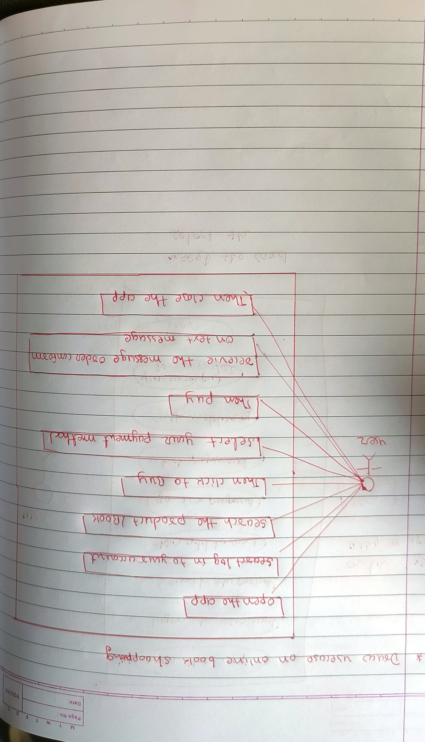

11 Draw Use case on online bill payment system (Paytm)?

* 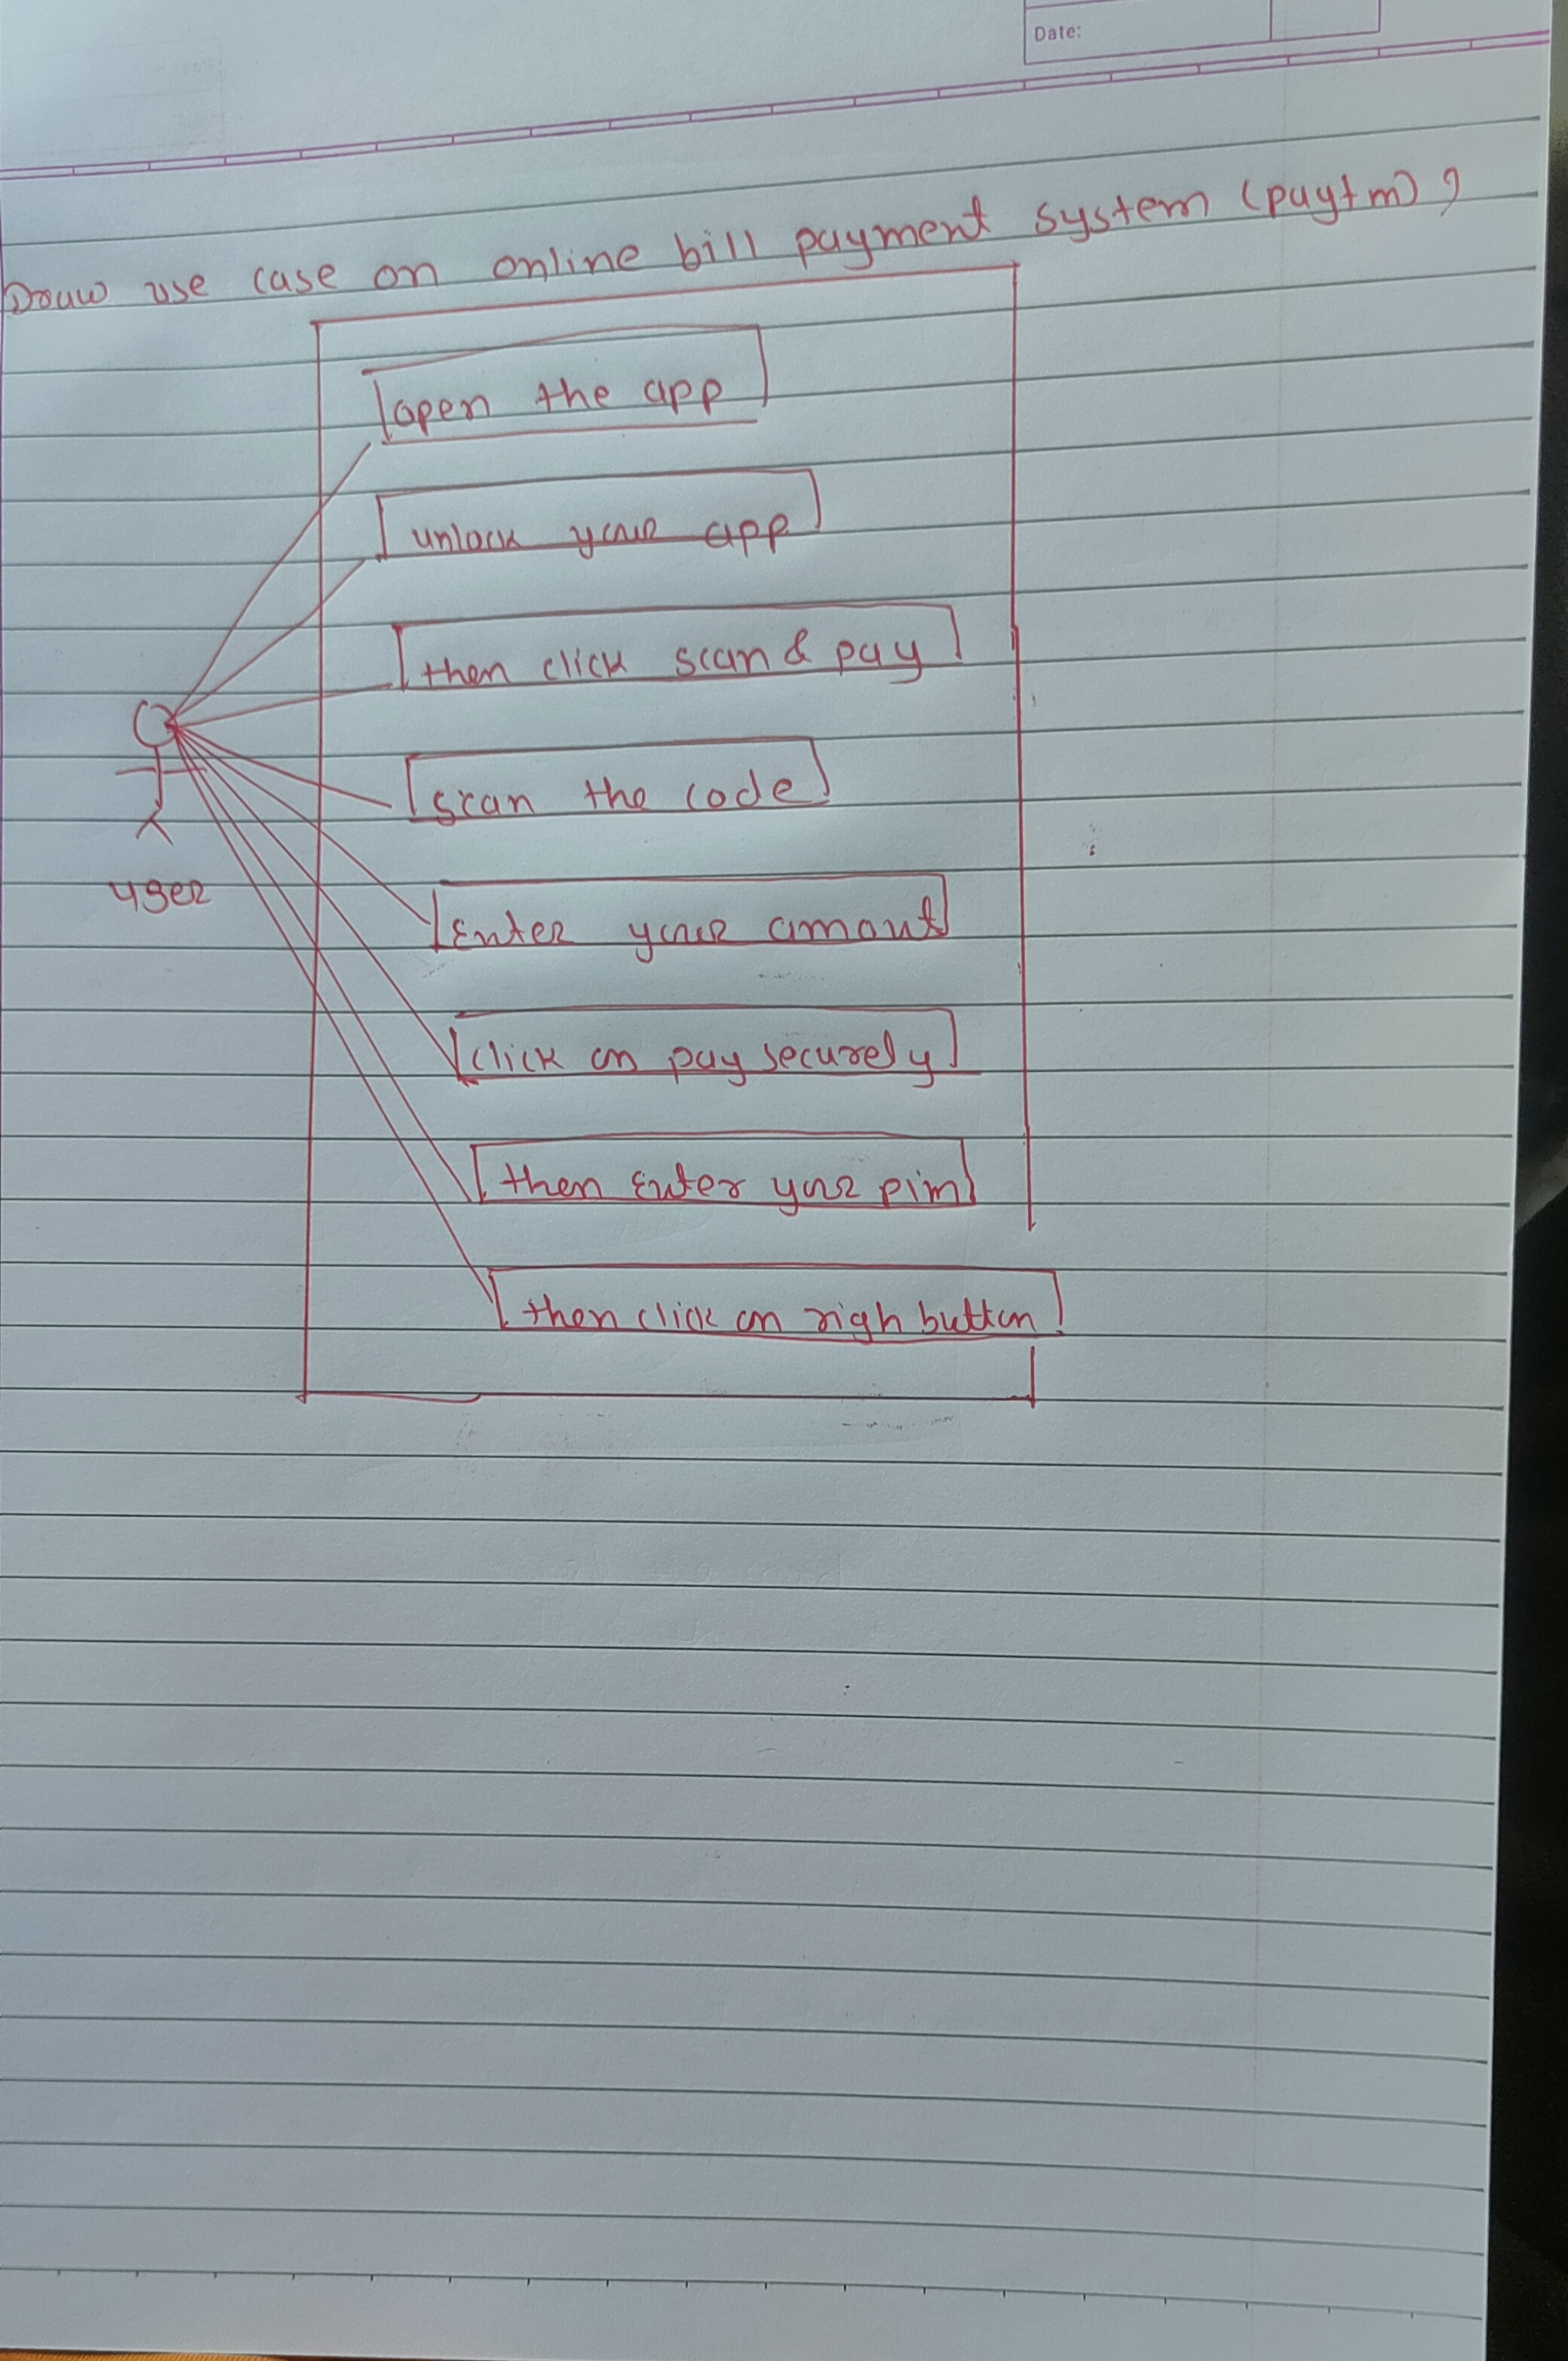

12 Write SDLC phases with basic introduction?

* The Software Development Life Cycle (SDLC) is a systematic process for planning, creating, testing, deploying, and maintaining information systems.
* There are 6 phases.
* [**Requirements gathering and analysis:**](https://www.geeksforgeeks.org/requirements-gathering-introduction-processes-benefits-and-tools/) This phase involves gathering information about the software requirements from stakeholders, such as customers, end-users, and business analysts.
* **Design:** In this phase, the software design is created, which includes the overall architecture of the software, data structures, and interfaces.
* **Implementation or coding:** The design is then implemented in code, usually in several iterations, and this phase is also called as Development.
* **Testing:** The software is thoroughly tested to ensure that it meets the requirements and works correctly.
* **Deployment:** After successful testing, the software is deployed to a production environment and made available to end-users.
* **Maintenance:** This phase includes ongoing support, bug fixes, and updates to the software.

13 Explain Phases of the waterfall model?

* 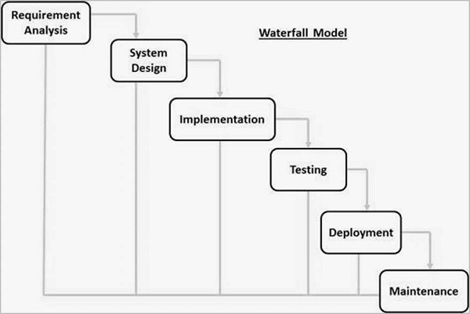
* **Requirement Gathering and analysis** − All possible requirements of the system to be developed are captured in this phase and documented in a requirement specification document.
* **System Design** − The requirement specifications from first phase are studied in this phase and the system design is prepared. This system design helps in specifying hardware and system requirements and helps in defining the overall system architecture.
* **Implementation** − With inputs from the system design, the system is first developed in small programs called units, which are integrated in the next phase. Each unit is developed and tested for its functionality, which is referred to as Unit Testing.
* **Integration and Testing** − All the units developed in the implementation phase are integrated into a system after testing of each unit. Post integration the entire system is tested for any faults and failures.
* **Deployment of system** − Once the functional and non-functional testing is done; the product is deployed in the customer environment or released into the market.
* **Maintenance** − There are some issues which come up in the client environment. To fix those issues, patches are released. Also to enhance the product some better versions are released. Maintenance is done to deliver these changes in the customer environment.

14 Write phases of spiral model?

* Planning
* Risk analysis
* Engineering
* Customer evaluation

15 Write agile manifesto principles?

* Individual interaction
* Working software
* Customer collaboration
* Response in to change

16 Explain working methodology of agile model and write pros and cons?

* Agile methodology is project management and product development approach that prioritises development approach that prioritize flexibility, collaboration and customer satisfaction.
* Agile Methods break the product into small incremental builds.
* These builds are provided in iterations.
* Pros: =
* Is a very realistic approach to software development
* Promotes teamwork and cross training?
* Functionality can be developed rapidly and demonstrated.
* Cons: =
* Not suitable for handling complex dependencies.
* More risk of sustainability, maintainability and extensibility.
* An overall plan, an agile leader and agile PM practice is a must without
* which it will not work.

17 Draw use case on Online shopping product using COD.

* 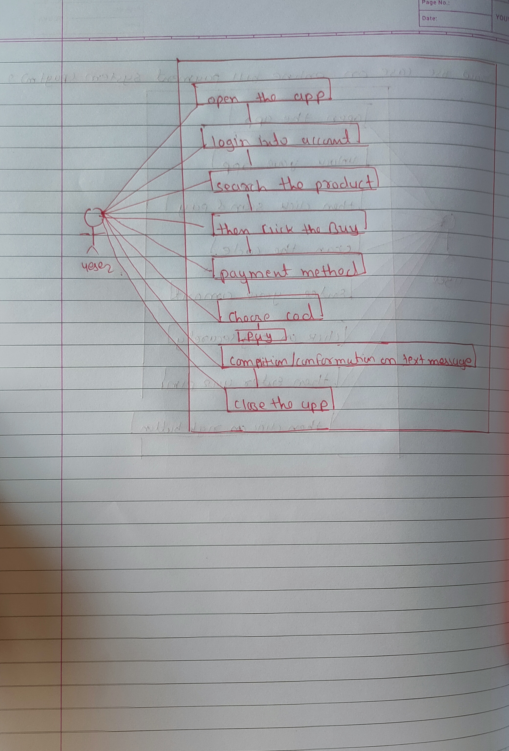

18 Draw use case on Online shopping product using payment gateway.

* 